Micro Services Challeges

1) Bounded Context --->Ideantify the Boundary of each microsevises(this means find the dividing monolithic to microserives)

2) Configuration Management : confoguration files distigues to all microserives

3) Dynamic Scale up and scale down microservices instances

4) visibity --> find bugs in all microservises.(which microservises is down and bug)

5) pack of cards -->if one microsevises is talk to another microsevises .if any microsevises down its collapse entire application (fault tollarance)

Spring cloud

To solve above challeges we can use Spring cloud

Configuration Management
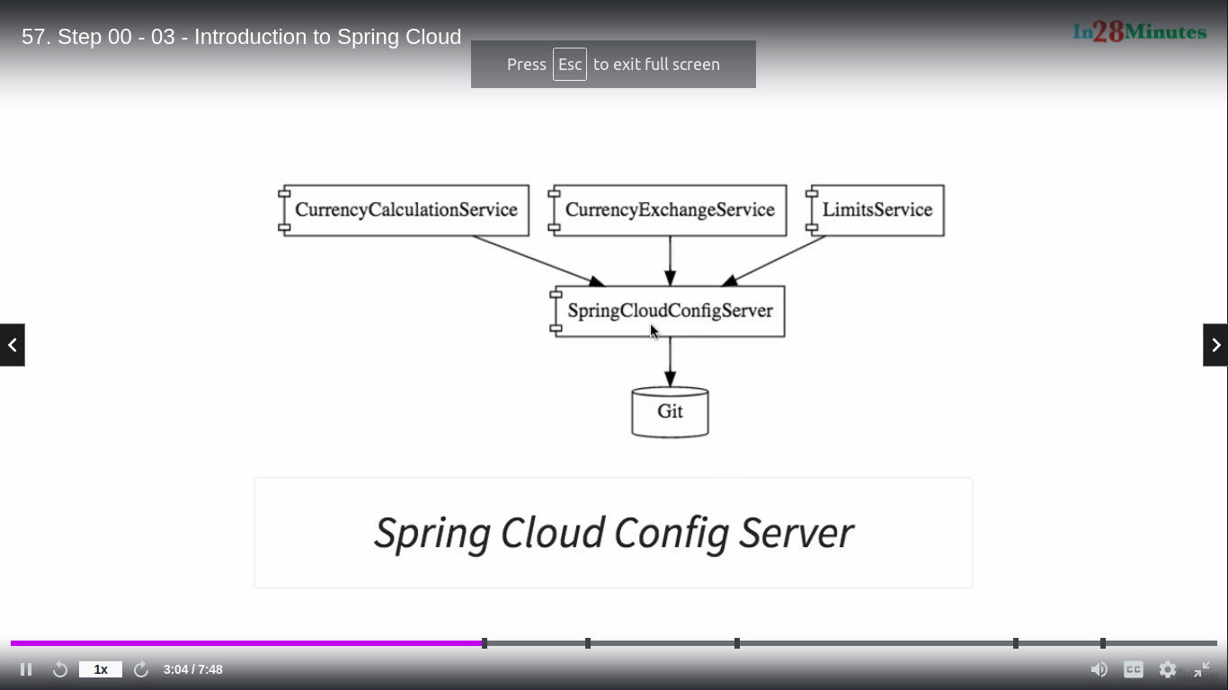

Visibility and Monitoring
----------------------------------

Zipkin distributed tracing
Netflix API Gateway (Zuul) -->security provided all microservices

Fault Tolarence
--------------------
Hystrix

Dynamic Scale up and scale down

1) Naming Server (Eureka Server)
2) Ribbon (client side load balancing)
3) Feign (Easier Rest Client)

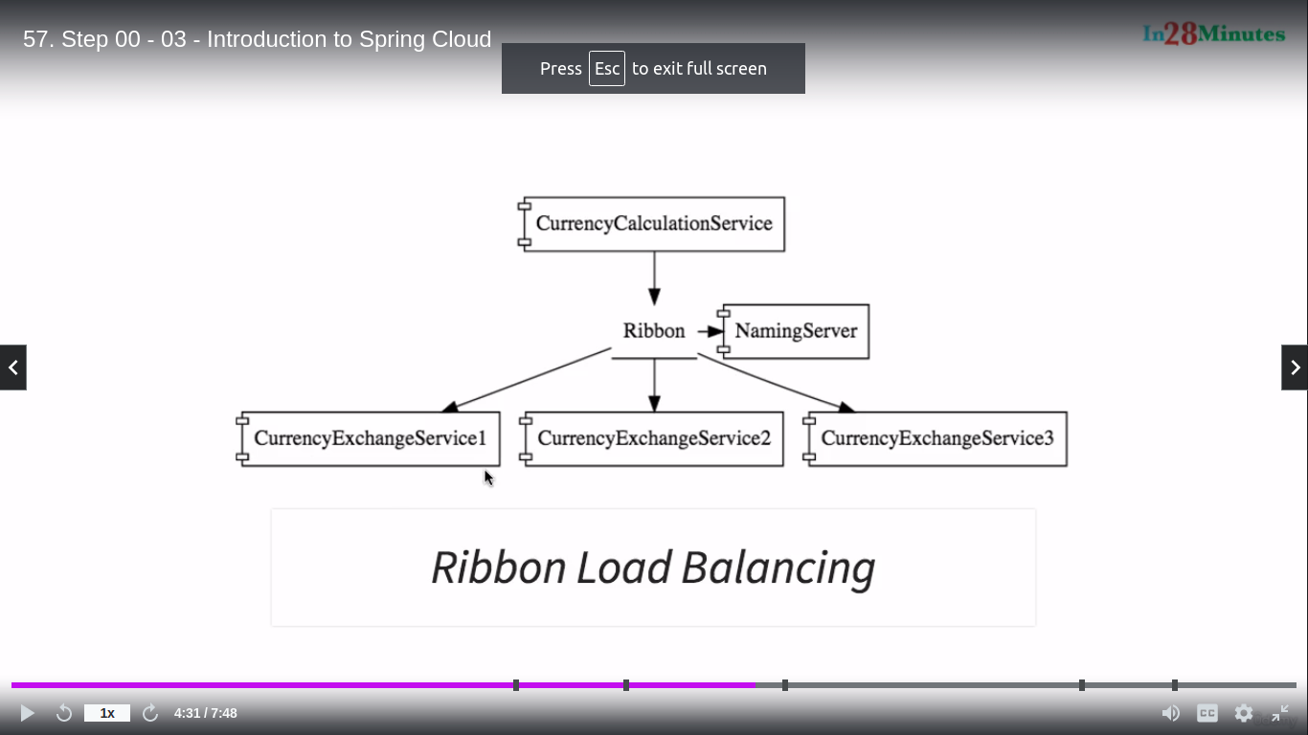
Spring boot 2
-----------------
!) Naming server -->netflix-eureka-server
2)Discovery Client -->netflix-eureka-client
3)Ribbon --->Feign(openfeign)
4)Hytrix(Fault Tollarance) --->circuitbreaker-resilience4j
5)sleuth & zipkin & RabbitMq
-->sleuth is used for generate trackingid for each request.
-->zipkin is server to store all information about request and response (to find the where exactly its fail the request)
-->RabitMq is used for if Zipkin server is down .all the tracking request data is available in rabbitmq.once zipkin server is up all request will be stored in zipkin

